
Declaration of Entry into Force of Ongoing Power of Attorney or Medical Power of Attorney
This website enables the Representative to upload a declaration of entry into force, without the need to appear in person before the District Guardian General. In order for you to be able to upload the documents, the Representative is required to register in the "Government Identification System" as specified in this file.

- Enter the General Guardian website – submission of documents for Ongoing POA

- Click on the blue button shown below - "Edit and Deposit of "Ongoing Power of Attorney online”

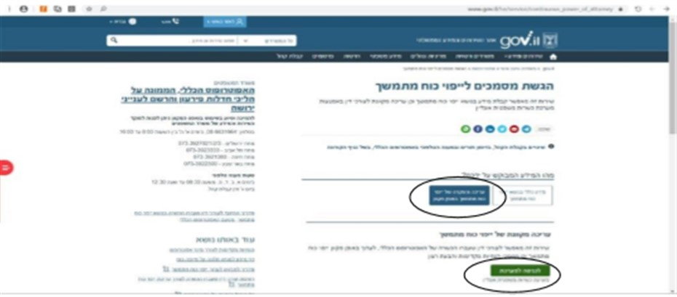
- Click on the green button shown below – "Enter the System"

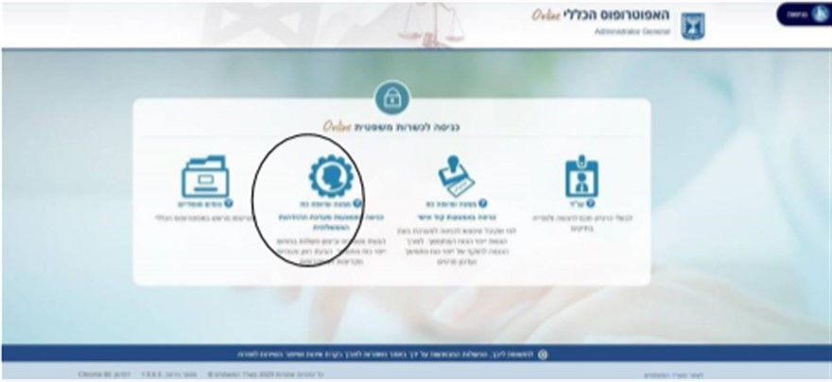
Select the icon "Grantor and Representative – entry through the Government Identification System" (circled in the diagram below)

At this point, a window will open: "Government Identification System"
  - If you have already registered for the site, please skip to page 5 in this file.

- A citizen who is not registered on the website of the Government Identification System – click on the "Registration" tab and enter the registration form, in order to register on the website:
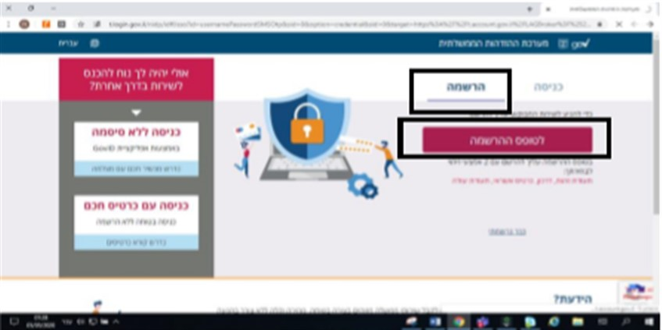

- Step 1: The "Register for the Government Identification System" window will open. Fill in the details:

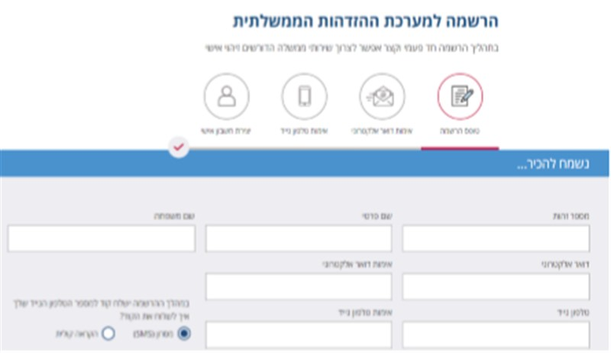

- Step 2: Choose from 2 of the 4 identification options:
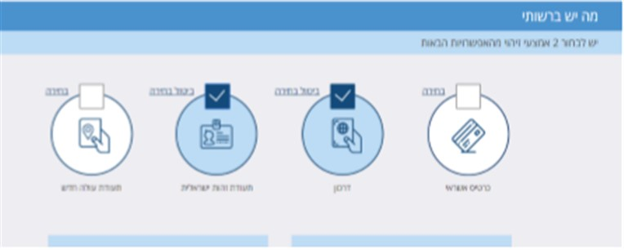

- Step 3: The identification details must be filled in according to the instructions:
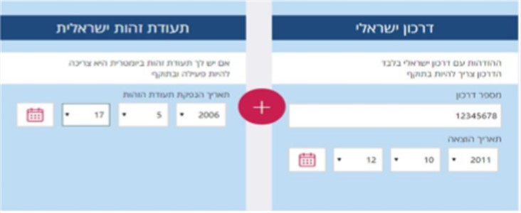

- Step 4: A password must be selected as requested. In the next line, verify the password again (to check the selected password, you can click on the eye icon).
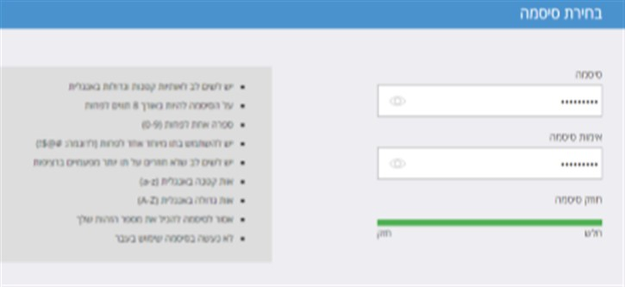

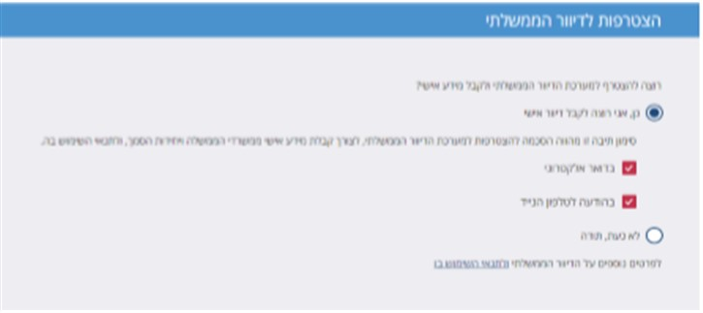
- Step 5: The application to join the government mailings should be marked

- Last Step: The terms of use must be confirmed and then click the red rectangle "Submit".
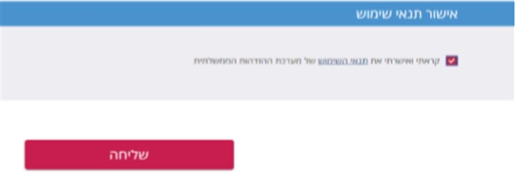

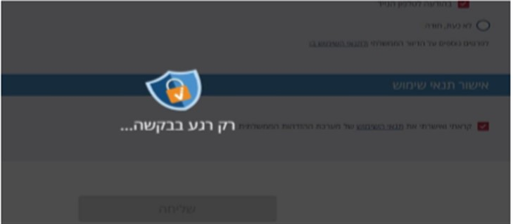

- At the end of the registration, you will receive a message: "The registration was successful".

After completing the registration process, you can submit a declaration of entry into force, without having to appear in person before the district Guardian General. For this purpose, the process must be continued as a registered citizen in accordance with what is detailed on the following page:

If you are a registered citizen – click on the "Login" tab

- Insert your ID number and the password selected at the time of registration and then click on the red rectangle
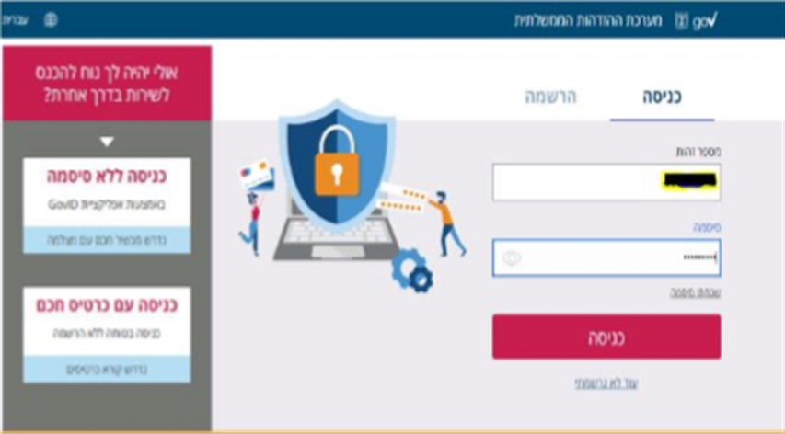

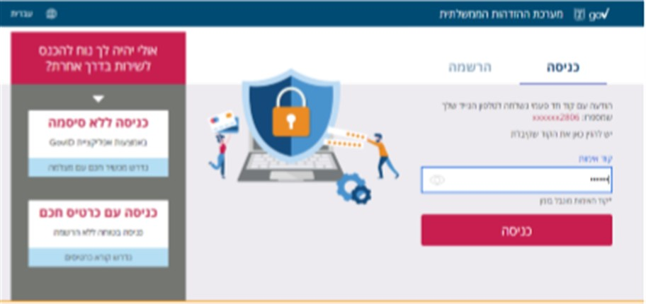
- At this point, an access code will be sent to the mobile phone number you entered when registering. Type in the code received and click on the red rectangle "Login".

Now, the personal area will be open on the "Legal Capacity Online" site. Your name will be displayed at the top of the page.

- The case/s in which you serve as a Representative will be presented in a table.
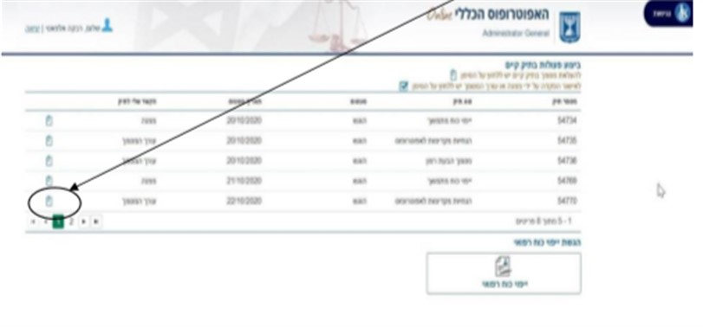
- Select the file in which you want to submit a declaration of entry into force, by clicking on the gray folder icon.

- On the page that opens, follow the instructions and select the type of document requested to be uploaded – "A notice of entry into force of an Ongoing Power of Attorney" or "A notice of entry into force of a Medical Power of Attorney":
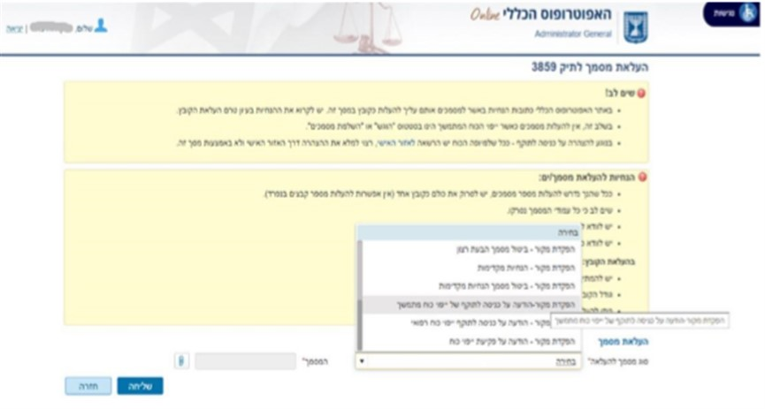

Please note!
The declaration document must be prepared in advance and saved on a computer in PDF format only.
- For an explanation of how to fill in the "declaration of entry into force", click here, and select the tab "Continue processing the application".

- To print the "declaration of entry into force" and for its completion click here, select the "Download files" tab, and click on the requested declaration form (you can select a declaration form for printing and for filling in manually, or a declaration form for filling in by typing and then for printing).

- Please carefully read the instructions in the activation panel before uploading the declaration and other documents, to the extent relevant.
- In the "District" tab, select the district that matches the Grantor's place of residence, and upload the document/s in PDF format.

- After uploading the document/s, click on the blue rectangle –

- You will then receive a message:

