Benchmarking – Timetables in Civil Litigation

Canada - Ontario

Background to the new rules of civil procedure (2010):
http://www.attorneygeneral.jus.gov.on.ca/english/courts/civil/changes_to_rules_of_civil_procedure.asp

Flowcharts summarizing the process and timelines:
http://www.attorneygeneral.jus.gov.on.ca/english/courts/civil/changes_to_rules_of_civil_procedure_flowcharts.pdf#page=4

Canada- Quebec
New code of civil procedure (2014)
Background:
http://www.justice.gouv.qc.ca/english/sujets/glossaire/code-proc-a.htm#highlights
The text of the new code:
http://www2.publicationsduquebec.gouv.qc.ca/dynamicSearch/telecharge.php?type=2&file=/C_25/C25_A.HTM

Specific relevant sections:

CHAPTER IV
CASE MANAGEMENT

SECTION I
AGREEMENT BETWEEN PARTIES AS TO CONDUCT OF PROCEEDING

151.1. Before the date indicated in the notice to the defendant for presentation of the action or application, the parties, except impleaded parties, must negotiate an agreement as to the conduct of the proceeding, specifying the arrangements between them and the timetable with which they are to comply within the 180-day or, in family matters, the one-year peremptory time limit.

Any person impleaded in the motion to institute proceedings who wishes to take part in the negotiation of the agreement determining the proceeding timetable must notify the parties within five days of service of the motion. Otherwise, the person is presumed not to wish to do so.

The agreement must cover, among other things, the preliminary exceptions and safeguard measures, the procedure and time limit for the communication of exhibits, written statements in lieu of testimony and detailed affidavits, the number and length of and other conditions relating to examinations on discovery before the filing of the defence, expert appraisals, any planned or foreseeable incidental proceedings, the oral or written form of the defence and, in the case of a written defence, the time limit for its filing as well as the time limit for filing an answer, if one is to be filed. The agreement must be filed without delay at the office of the court, no later than the date fixed for presentation of the action or application.

2002, c. 7, s. 19; 2004, c. 14, s. 2.

151.2. The agreement is binding on the parties as to the conduct of the proceeding. The parties may modify the agreement, insofar as the modification does not contravene the 180-day or, in family matters, the one-year peremptory time limit. If there is a disagreement between the parties, the court may, on request, authorize any modification it considers appropriate.

2002, c. 7, s. 19; 2004, c. 14, s. 3.

151.3. The parties must comply with the timetable they have set under pain of the penalty prescribed by this Code or, in the absence thereof, of dismissal of the action or application, striking of the allegations involved or foreclosure, as appropriate. However, the judge may, on request, relieve a defaulting party from default if required in the interest of justice; the costs resulting from the default are borne by the party concerned, unless the judge decides otherwise.

2002, c. 7, s. 19.

UK
Civil Procedure Rules
Introduction:
http://www.hilldickinson.com/pdf/The%20English%20Civil%20Procedure%20Rules.pdf

Typical timelines:
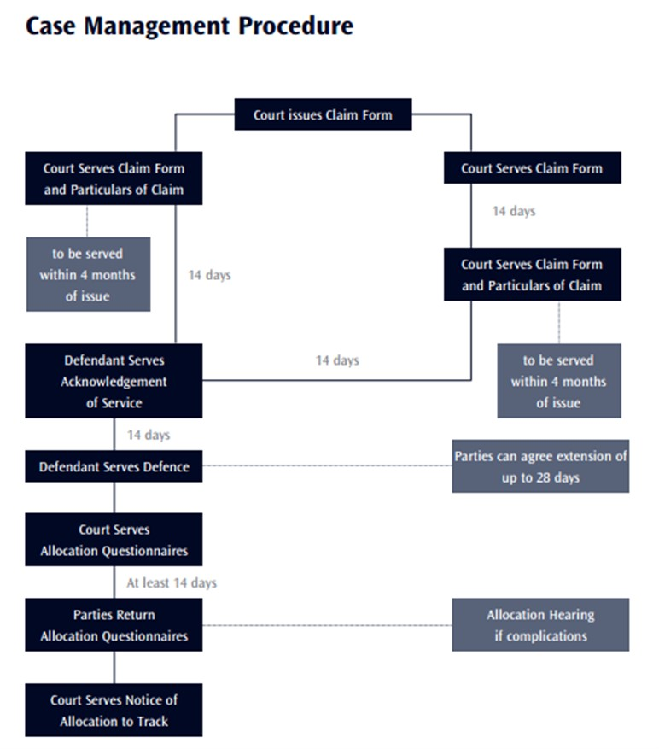

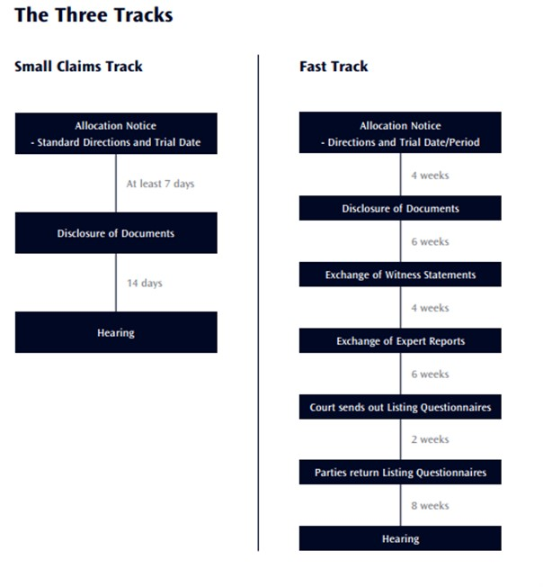
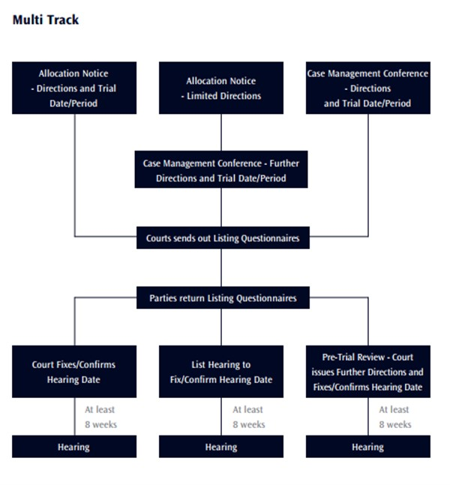

Queen’s Bench

https://www.justice.gov.uk/downloads/courts/queens-bench/queen-bench-guide.pdf

2.3 Time Limits:
2.3.1 There are strict time limits that apply to every claim. First, there are time limits fixed by the Limitation Act 1980 [and some other Statutes, such as the Human Rights Act 1998 and the Defamation Act 1996] within which proceedings must be brought.
There are circumstances in which the court may extend those time limits, but this should be regarded as exceptional. In all other cases, once the relevant time limit has expired, it is rarely possible to start a claim.
2.3.2 Secondly, in order to try and bring the proceedings to an early trial date, a timetable will be set with which all parties must comply. Unless the CPR or a Practice Direction provides otherwise, or the court orders otherwise, the timetable may be varied by the written agreement of the parties. However, there are certain "milestone" events in the timetable for which the parties may not vary the time limits. Examples of these are;
1. return of the Allocation Questionnaire/Reply to Defence, which should be returned together with the Allocation Questionnaire
2. date for the case management conference
3. return of the Pre Trial Checklist
4. date fixed for trial.
5. Defence when time has elapsed following the days from service of Particulars of Claim on the Defendant (CPR 15.5)
Where parties have extended a time limit by agreement, the party for whom the time has been extended must advise the Registry Section in writing of the appropriate event in the proceedings for which the time has been extended and the new date by which it must be done. For example, if an extension is agreed for the filing of the defence, it is for the defendant to inform the Registry Section.
2.3.3 The court has power to impose a sanction on any party who fails to comply with a time limit. If the court considers that a prior warning should be given before a sanction is imposed, it will make an ‘unless’ order; in other words, the court will order that, unless that party performs his/her obligation by the time specified, s/he will be penalised in the manner set out in the order. This may involve the party in default having his/her claim or statement of case struck out and judgment given against him.
An Order striking out a claim or statement of case must be applied for after the time specified has expired, as this is not automatic unless the Unless Order so provides.

